**Kathmandu University**

**Department of Computer Science and Engineering**

**Dhulikhel, Kavre**



**A Mini-Project Report on**

**“Color Cube Flyby-C++”**

**[COMP 306]**

(For partial fulfillment of 3nd Year/2nd Semester in Computer Engineering)

**Submitted by:**

Prajwol Manandhar(32)

**Submitted to:**

Dhiraj Shrestha

Assistant Professor

Department of Computer Science & Engineering (DoCSE)

**Submission Date:**

May 21, 2022

Table of **Contents**

Chapter1: Introduction 3

1.1 Introduction of Library Used(OpenGL) 3

Chapter2: Code Breakdown: 4

2.1 Libraries 4

2.2 Defining Cube Properties 4

2.3 Defining Cube Vertex Positions 4

2.4 Defining Cube Faces 4

2.5 Defining Vertex Colors (R, G, B) 5

2.6 Defining a Cube Drawing Function 5

2.7 Clearing Buffers 5

2.8 Setting timer 5

2.9 Setting Perspective of Camera 6

2.10 Backface Culling 6

2.11 Defining the main() Funciton 6

Additional Materials 11

Appendices: 12

# Chapter1: Introduction

ColorCube Flyby as stated in the name is a project in which we rotate the perspective of the vision about a 3d multicolored cube in a closed orbit. Here the Cube is in the fixed space with fixed color in its faces and vertices. Then we look in the direction of the center of the cube while we are moving about an orbit around the cube.

## Introduction of Library Used(OpenGL)

We have used GLUT library and C++ language along with their respective libraries to complete the project.

GLUT is the OpenGL Utility Toolkit, a window system independent toolkit for writing OpenGL programs. It implements a simple windowing application programming interface (API) for OpenGL. GLUT makes it considerably easier to learn about and explore OpenGL Programming.

C++ is a general-purpose programming language and is widely used nowadays for competitive programming. It has imperative, object-oriented and generic programming features. C++ runs on lots of platforms like Windows, Linux, Unix, Mac etc.

# Chapter2: Code Breakdown:

## 2.1 Libraries

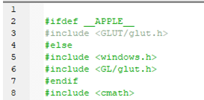

We have used <windows.h>, <glut.h>, <cmath> libraries:

<Windows.h> : Helps the code to work with windows OS

<glut.h> : Library for all the OpenGL Codes

<cmath> : C++ library for common mathematical operations and tarnsformations

## 2.2 Defining Cube Properties

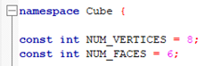

## 2.3 Defining Cube Vertex Positions



## 2.4 Defining Cube Faces



## 2.5 Defining Vertex Colors (R, G, B)



## 2.6 Defining a Cube Drawing Function

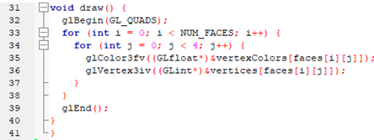

## 2.7 Clearing Buffers

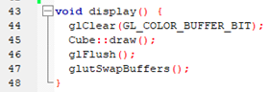

This function clears the window to draw the cube and is used to achieve the animation by successively drawing presenting the view as in frames based on the movement of the camera.

## 2.8 Setting timer

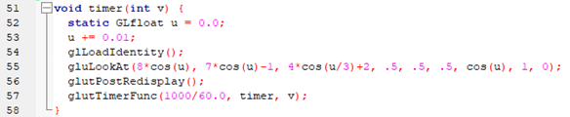

## 2.9 Setting Perspective of Camera

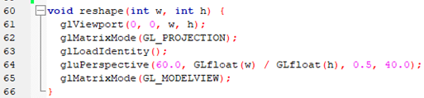

## 2.10 Backface Culling

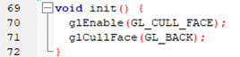

## 2.11 Defining the main() Funciton

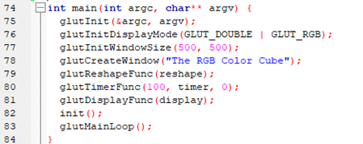

Output:

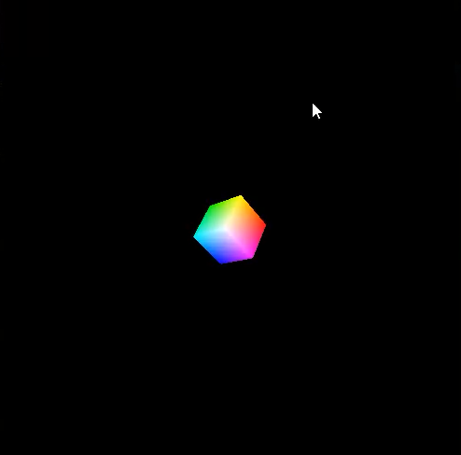

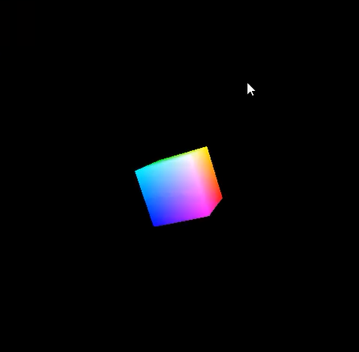 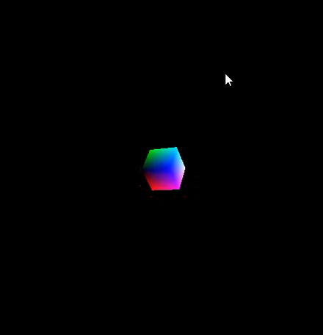

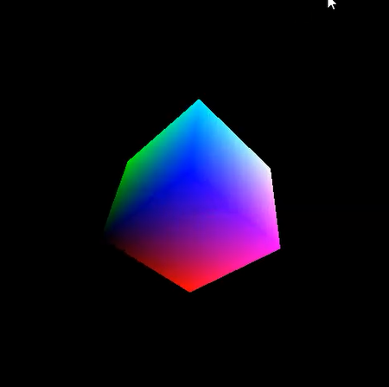

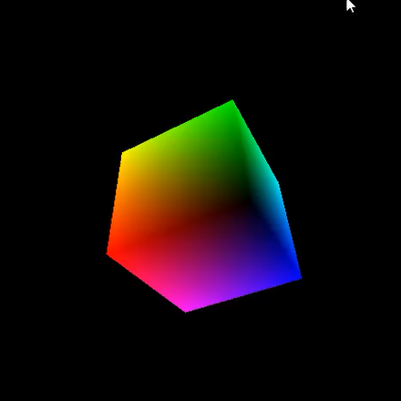



# Additional Materials

The video of the code explanation and the output running is in the given git hub link:

https://github.com/PrajwolM/Colocube-Flyby.git

# Appendices:

